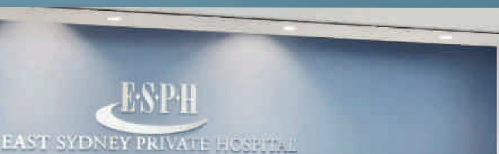
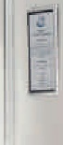
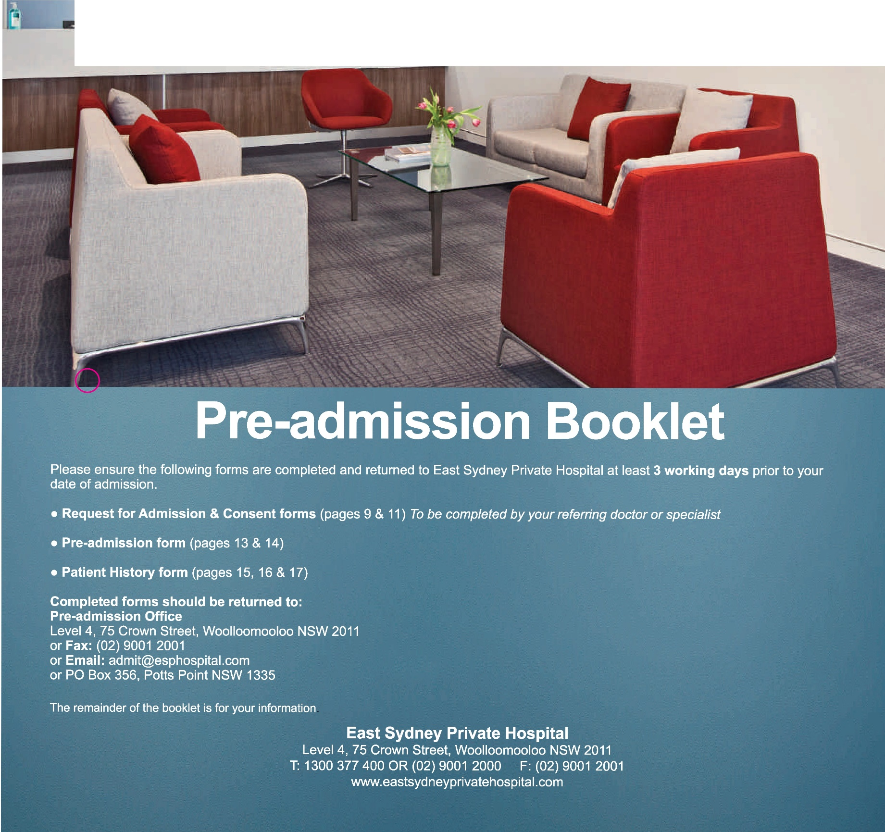

0

Welcome to
East Sydney Private Hospital
At East Sydney Private Hospital we are committed to providing patients with the highest standards of health care. Our staff will ensure that throughout your stay you will be looked after with the utmost respect and dignity.
Please complete the admission forms contained within this booklet and return them to East Sydney Private Hospital at least 72 hours prior to your admission. Should you need assistance completing the forms please contact the hospital on (02) 9001 2000.
After you have returned the forms to the hospital, a staff member may contact you to get further information or to provide you with additional pre-admission information.

Anaesthesia and your procedure
Virtually all surgical procedures require some form of anaesthesia which will be administered by an anaesthetist. You will be seen by your anaesthetist before your procedure.
Please carefully complete the Patient History forms, as the information on these forms will be used by your anaesthetist to assess your specific anaesthetic requirements. Please take special care to record:
- All medications you are taking, the dose you are taking and how often you are taking the medications, including any complementary (herbal /alternative) medicines.
- Any serious medical problems such as heart disease, asthma or diabetes
- Any allergies or drug sensitivities
- Usage of recreational drugs, tobacco or alcohol
- Past anaesthetic experiences
- Loose or broken teeth, caps, plates, implants or dentures.
All this is important in minimising risk and may influence the type of anaesthetic provided.

Preparing for your anaesthetic
There are several simple things that you can do to improve your general condition prior to your procedure:
- Moderate exercise such as walking will improve your general physical fitness and aid your recovery
- Cease smoking as soon as possible, ideally six weeks prior to surgery
- Carefully follow the fasting and medication instructions on page 2 of this booklet. If these instructions are not followed, your procedure may have to be postponed in the interest of your safety
- Contact your surgeon or anaesthetist if you have any questions, concerns, or are anxious about your anaesthesia.

Your medications
If you take any regular medication (including non-prescription medications) you should discuss this with your doctor. You may need specific instructions regarding which medications you should cease and which you should continue.
Generally, you should take your regular morning medication at 6.00am with a sip of water (ie. 30mls). If your procedure is in the afternoon and you usually take your medication at lunchtime, you should take those at 11am with a sip of water (ie. 30mls).

Exceptions to this are:

Aspirin and anti-inflammatory medications
  - All patients should cease taking these medicines 10 days prior to your procedure unless you are taking it for your heart or for stroke prevention. If you are
taking aspirin, clopidogrel (Plavix or Iscover), warfarin
or anticoagulants for a heart condition or stroke prevention, you should seek specific instructions from your surgeon and cardiologist as to when or if these medications should be ceased.
  - Patients with coronary artery stents, any vascular stent or cardiac implant should discuss with their cardiologist or surgeon before ceasing the drugs listed above.

Diabetic Medications
  - For all patients taking diabetic medications it is important that you discuss your diabetes medication instructions with your doctor prior to your procedure.

Herbal (complementary / alternative) medicines
  - if you are having a procedure, you should cease taking these medicines for 10 days prior to your procedure unless otherwise instructed by your doctor.

The day of your procedure

Fasting
Generally you should not eat or drink for at least six hours prior to your procedure, unless your doctor has indicated otherwise.
The fasting time may vary, depending on the type of anaesthetic you are having. You will be advised when to commence fasting by hospital staff prior to your admission.

If fasting instructions are not followed, your procedure may have to be postponed in the interests of your safety.

Your arrival time
A member of staff will contact you between 2.00pm and 6.00pm on the afternoon prior to your admission to notify you of your required arrival time.
The hospital will endeavour to minimise your waiting time. However, there may be longer than expected waiting times if unforeseen events arise with other patients undergoing procedures or if pre-operative reviews or tests are requested by your doctors in the interests of your care.

What to bring
    - All entitlement cards e.g. Medicare / Safety Net / Veterans’ Affairs and Health Fund cards
    - Any paperwork not already forwarded to the Hospital
    - Relevant x-rays, scans or films
    - Current medication (in their original containers) and prescriptions
    - Payment for estimate of gap between fund benefits and hospital fees, or total estimated costs of hospitalisation if you have no health insurance
    - Reading material and/or something else to do
    - A hard case for your glasses
    - Aides such as walking stick, hearing aids
    - For a child – favourite toy, formula, bottle and any special dietary needs (if applicable)
    - Children may go to the procedure/theatre in their own pyjamas – these must be cotton with plastic buttons (no metal press studs) and be loose fitting.
If you are staying overnight, please remember to also bring (in a small overnight bag):
    - Sleepwear, dressing gown and slippers
    - Personal toiletries

Do not bring:
    - Valuables, including jewellery, and large sums of money (unless settling your account in cash on admission)
    - Unnecessary clothing
    - Large luggage and suitcases (these cannot be accommodated).

Prior to your procedure
Please:
    - Shower with soap on the day of your procedure
    - Do not apply any powder, creams, lotions or makeup
    - Please follow instructions from your doctor and hospital nursing staff, including fasting instructions
    - Wear comfortable clothing
    - Do NOT smoke.

Your hospital account
The hospital will provide an estimate of the gap between your health insurance cover and the hospital costs prior to your admission. This will be an estimate only, and in the event of unforseen variations or complications of the proposed treatment the cost may vary.
Full fee paying patients will be required to pay 100% of the estimated fee on arrival to East Sydney Private Hospital, unless otherwise negotiated with the facility.
Circumstances may also occur during your hospitalisation that will result in fee changes. Fees for some services cannot be estimated prior to your admission.
While no guarantee can be given, every effort will be made to accommodate your room request. If you are allocated a private room, a gap payment will apply if your health insurance cover does not include private room fees.
Payment for your estimated gap is required on or before admission. East Sydney Private Hospital offers several options to pay your estimated gap or other accounts. These are BPay, post (bank cheque or money order only), or by presenting in person (cash, bank cheque, EFTPOS, credit card). Please note, credit cards will incur a surcharge.

Your Doctors’ accounts
Accounts from your treating doctors are separate and may not be usually fully covered by your health fund or Medicare. Please contact your treating doctors directly for estimates and/or to settle these accounts.
Please let your doctor and your anaesthetist know as soon as possible if your medical bills are to be paid by a third party such as worker’s compensation or the Department of Veterans’ Affairs.

Privately insured patients
Please check with your private health insurer that your insurance is up to date.
The hospital will check on your behalf whether you have an excess or co-payment to pay, or if your level of cover or waiting period excludes you from receiving benefits for some conditions. However, it is important that you also check with your private health insurer as co-payments and costs for excluded procedures are your responsibility.

Uninsured patients
If you do not have health insurance, you will be required to pay the full estimate of your account on or before the day of your admission. Fees for additional or unplanned services are payable on or after the day of your discharge.

Veterans
While no guarantee can be given, every effort will be made to accommodate your room request. As DVA does not cover veterans for private room accommodation, a gap payment will apply for each day you occupy a private room.
If you require transport to or from hospital, you will need to contact the Department of Veterans’ Affairs to make arrangements.

Workers’ Compensation and third party patients
All Workers’ Compensation, public liability and third party patients require approval from their insurer prior to admission. If approval is not received, the patient is required to pay the estimated amount on or before the day of admission.
The telephone number for all accounts enquiries is

(02) 9001 2000.

What costs could I incur that will not be covered by my health fund
- Pharmacy (medicines required during your admission and discharge medications)
- Pathology
- Imaging or x-ray
- Medical and allied health practitioners fees may be billed separately by the practitioner. Please discuss these with your doctor before your admission. You may receive separate accounts for:
Surgeon Anaesthetist Assisting surgeon Other consultants
- STD telephone calls

Infection Control
The hospital is committed to promoting infection control awareness to both staff and patients. All patients and visitors are encouraged to either wash their hands or use the alcohol based hand rubs to assist with reducing the risk of infection.
We also ask that visitors with colds, gastroenteritis or other contagious diseases do not visit the hospital, in order to prevent the spread of these infections.

Falls Prevention
Hospitals can be unfamiliar environments and combined with surgery, feeling unwell and taking certain medications patients can be at a greater risk of falling whilst in hospital.
To assist in preventing falls patients should observe or be aware of the following;
- Some medications can cause you to be light headed or drowsy. If you feel unsteady please ensure you contact a nurse to assist you.
- Please review the layout of your room during the day so that at night if you move around the room you will be better aware of your surroundings.
- Check floors in vinyl areas such as bathrooms to ensure they are not wet. If showering please use handrails or shower chairs as required.
- Your doctor may have requested you to wear pressure stockings. Pressure stockings can be slippery on polished floors thus you should also wear slippers when walking around the hospital.

Medication Safety
On admission to hospital please provide your nurse with any tablets or medicines that you have been taking before admission. These will be secured in a personal drug cabinet. Any additional medication you require whilst you are in hospital will be ordered by your doctor and supplied to you. Please note that some medications which you took prior to your surgery, your doctor may decide to withhold temporarily. When you are discharged, medications that you are required to take will be either provided to you as a prescription or as pharmacy supplied medications.

Pressure Injury Prevention
A pressure injury is an area of skin that has been damaged due to unrelieved pressure. Redness on the skin may appear to be minor, but can hide more damage under the skin surface.
It is important that you relieve pressure by keeping active and changing your position frequently when you are lying in bed or sitting in a chair. If you are unable to move by yourself, the staff will help you change your position regularly.
Please tell staff if you have any tenderness, or soreness over a bony area or if you notice any reddened, blistered or broken skin.

Blood Clot Prevention

Blood clotting is the body’s natural way of stopping itself from bleeding. Clotting only becomes an issue when it is
in the wrong place and blocks blood flow. Being immobile is a big risk in developing a clot and so blood clotting can increase when you are staying in hospital and spending a long time immobile (eg laying in bed or sitting in a chair for long periods of time).
In addition, there are a number of risk factors for blood clots, these include previous strokes, inherited blood clotting abnormalities, lung disease, being overweight, having had major surgery in the past, heart failure, smoking or contraception medications. If you have any of these risk factors, please alert your doctor or the staff.
While in hospital, staff will assess your risk of developing a clot and may ask you to wear compression stockings, compression sleeves, or you may be prescribed blood thinning medication.
Staying mobile, taking prescribed medications to reduce your risk of blood clotting and drinking plenty of fluid can
reduce your risk of clotting.
If you have sudden increased pain or swelling in your legs; pain in your lungs or chest; difficulty in breathing, please alert your nurse as soon as possible. If these symptoms occur after discharge, seek emergency treatment.

Your admission and hospital stay
ALL patients will be admitted via the Admissions Reception located on Level 4.
If you are unable to keep your appointment for admission or if you have any questions about your admission process, please contact us as soon as possible on (02) 9001 2000.

Visiting hours
General ward visiting hours are 10.00am to 8.00pm.
We ask that you advise your friends and relatives not to visit outside the visiting hours.

Leaving the hospital after Surgery
For the first 24 hours after your procedure it is important that you:
- Do not drive a car
- Do not drink alcohol
- Do not remain on your own (unless approved by your specialist)
- Do not make complex or legal decisions
You should be in the company of a responsible adult for 24 hours after a procedure.
After your operation you may need to follow detailed instructions. These may include wound or medication instructions. As you may have had an anaesthetic, we advise that a responsible adult be with you during these
discussions as it is important your discharge instructions
are understood.
Following discharge from the hospital, you will require someone to drive or accompany you home. Day patients can be met in the Day Surgery Discharge Lounge located on Level 4.
For overnight patients, discharge is prior to 10.00am. We ask you to vacate your room by this time to allow us to prepare for the next patient.

Hospital Policies

Smoking policy
East Sydney Private Hospital is a smoke free hospital. Smoking is not permitted in the hospital building or on its grounds.

Visitors Lounge
Lounge areas are provided for patients, their families and friends. Tea and coffee are provided.

Provision of food to patients by carers, relatives or friends
Please make staff aware of any food allergies, or intolerances you may have. Our staff will be able to assist you with your menu choices if required.
If your carer, relative or friend wishes to bring you meals from outside the hospital please let staff know as there are health and safety requirements concerning the safe transport and storage of food.

Patients’ rights and responsibilities
East Sydney Private Hospital is committed to delivering the highest possible standard of health care. All patients have rights and responsibilities when seeking medical treatment and care. We have provided below a list of your rights in relation to your ongoing treatment and care.

Patients’ rights
Access to Care – You have the right to:
- Receive treatment appropriate to your health needs
- Request a doctor of your choice
- Request a second opinion

Standard of health – You have the right to:
- Treatment directed and supervised by competent and qualified health professionals
- Know the names and professional status of staff providing care
- Dignity, courtesy and respect in all interactions with staff
- Care, treatment and service which is sensitive to your cultural and religious values and beliefs
Parents/guardian – You have the right to:
- Exercise all rights if you are the parent or guardian of a child
- Choose to stay with your child at all times, except when clinical reasons dictate
- Make decisions regarding consent to treatment of your child if under 14 years. After this age children may seek treatment and provide consent or make decisions jointly with their parents/guardian
Informed consent – Patients have the right to:
- Refuse recommended treatments
- Withdraw consent to treatment at any time
- Refuse to have treatment, which is experimental
- Leave the hospital at any time. If they leave without hospital consent, the patient is responsible for any injury or illness caused or aggravated by their own action

Right to information
You have the right to access information contained in your medical record. East Sydney Private Hospital provides such access in accordance with relevant legislative and policy guidelines. While in hospital you may contact your nursing unit manager for assistance, or after discharge contact the Medical Records department.

Patients’ responsibilities

You have the responsibility to:
- Find out about your condition and treatment, including the range of treatments that may be available to you
- Know your medical history including details of any medication you are taking
- Answer questions about your health frankly and honestly
- Discuss any problems you feel may be affecting your health or medical condition
- Provide comprehensive and accurate health information to enable optimal care
- Cooperate fully with the doctor and clinical team in all aspects of your treatment
- Follow your treatment and inform your provider when you are not able to do so
- Keep appointments or let the provider know when you are unable to attend
- Pay the fees of the hospital and your attending doctor
- Consider the rights of other patients and staff members.
If you are aware of any particular condition that may cause undue harm to other patients or staff, this should be disclosed at time of admission.
When a health care worker becomes aware that a risk to public safety exists while managing a patient, they will be excused from breaching confidentiality when they disclose information about this risk in order to protect the public.

Personal information and privacy for patients
East Sydney Private Hospital recognises and respects every patient’s right to privacy. We will collect and use the minimum amount of personal information needed for us to ensure that you receive a high level of health care. East Sydney Private Hospital will always endeavour to manage your information to protect your privacy.

Personal information we usually hold:
- Your name, address, telephone and email contact details
- Health fund details
- Date and country of birth
- Next of kin
- Occupation
- Health information
- The name and contact details of your General Practitioner and your referring doctor
- DVA information
- Religious beliefs or affiliations (if provided)
- Marital status
- Transaction details associated with our services

What we do with personal information:
- We will collect it discreetly.
- We will store it securely.
- We will only provide your personal information to people involved in your care. We ask all doctors and health professionals who consult with other health care providers outside East Sydney Private Hospital to also protect your right to privacy.

- We will provide relevant information to your health fund, or the Department of Veterans’ Affairs, Medicare Australia, Cancer Council, NSW Department of Health or to other entities when we are required to do so by law.
- After removing details that could identify you, we may use the remaining information to assist with research and service improvement projects. We are also required to provide this kind of information to government agencies.
- East Sydney Private Hospital is a teaching hospital and we may use personal information in the training and education of medical, nursing and other allied health students.
- We will destroy our record of your information when it has become too old to be useful or when we are no longer required by law to retain it.
- We may use the information to contact you. By providing
your mail and/or email address, we assume permission to use this address for administrative communications (e.g. receipts) regarding your hospital visit. We will not send your health information via email.

Your rights
- You may give consent for us to use your personal information to provide you with health care services, or you may withdraw consent at any time.
If you withdraw consent for East Sydney Private Hospital to use your personal information, this may reduce our ability to provide you with services.
- You may ask us to limit access to your information. If you have a specific requirement for restricting access by someone to your information, please inform us about this as soon as possible.
- You may ask us to give you (or another individual) access to your personal information. In most cases we will
allow you to have access to your personal information.
We may charge a fee for providing printed copies of reports. We may not provide you (or your responsible person) with access to your personal information if a doctor feels that it may be harmful to do so.
- You may ask us to correct any error in your personal information.
- You may make a privacy-related complaint if you feel that the Hospital has not kept your information confidential or has not maintained your privacy - by telephoning the Hospital Manager (02) 9001 2000.

Feedback and Complaints
The hospital values patient feedback. If you have a suggestion, wish to report an incident or to give a compliment, there are several options.
  - Use the feedback form in your room, in the Discharge Lounge, or download the form from the website at www.esphospital.com
  - Speak to the person in charge of the department, usually the Nursing Unit Manager.
  - Should you prefer to speak to someone outside the department, please contact the The Hospital Manager during office hours Monday to Friday on telephone (02) 9001 2000.
Or you can write to: Hospital Manager
East Sydney Private Hospital PO Box 356
Potts Point NSW 1335
You may contact the Healthcare Complaints Commission if you are not satisfied that the Hospital has resolved your complaint.
Health Care Complaints Commission Locked Mail Bag 18
Strawberry Hills NSW 2012 Telephone: 1800 043 159 Website: www.hccc.nsw.gov.au

Commitment to improvement
The hospital values the contribution of our patients to our continuous improvement program. East Sydney Private Private Hospital complies with the National Safety and Quality Health Service (NSQHS) Standards and we have a quality management system based on the ISO 9001 standards which ensures our commitment to providing
excellence in care to patients and their relatives.

Pecuniary Interest
The following doctors have a financial interest in the hospital;
David Caminer Larry Kalish Daniel Novakovic David Robinson Peter Tsakiris Patrick Versace

Security and Safety Cameras
Patients and visitors are advised that security monitoring cameras are used within public areas of the hospital and car parks.
All cameras and clinical monitoring devices are in accordance with the Privacy and Personal Information Proction Act 1998 and Health Records & Information Privacy Act 2002.

Getting to East Sydney Private Hospital
Patients attending East Sydney Private Hospital can enter via the corner of Crown and Kennedy Street and take the main lifts to the 4th floor.

Transport
- Buses, Trains & Taxis
Regular bus services can be found in William Street and Crown Street within easy walking distance from the hospital. For timetable information, contact the transport Infoline on 131 500
- The nearest train station to the hospital is Kings Cross station which is an approx. 10-15 minutes walk.

Car Parking
Car parking facilities are available in Wilson carpark which is accessed via Kennedy Street. First 20 minutes are free. Fees apply for a longer stay.

Additional car parking can be found at The Sydney Boulevard Hotel, 90 William Street (3 min walk), or the Domain Car Park- entry via St Mary’s road (5 min walk).

Hotel Accommodation
Accommodation is available at The Sydney Boulevard Hotel at a discounted rate. Please ring the hospital reception on 9001 2000 and ask for a discount code.

The Australian Charter of Healthcare Rights describes the rights of patients and other people using the Australian health system. These rights are essential to make sure that, wherever and whenever care is provided, it is of high quality and is safe.
AUSTRALIAN CHARTER OF
HEALTHCARE RIGHTS
The Charter recognises that people receiving care and people providing care all have important parts to play in achieving healthcare rights. The Charter allows patients, consumers, families, carers and services providing health care to share an understanding of the rights of people receiving health care. This helps everyone to work together towards a safe and high quality health system. A genuine partnership between patients, consumers and providers is important so that everyone achieves the best possible outcomes.

Guiding Principles
What can I expect from the Australian health system?
MY RIGHTS
WHAT THIS MEANS
Access
I have a right to health care. I can access services to address my
healthcare needs.
Safety
I have a right to receive safe and I receive safe and high quality high quality care. health services, provided with
professional care, skill and competence.
Respect
I have a right to be shown respect, dignity and consideration.
Communication
The care provided shows respect to me and my culture, beliefs, values and personal characteristics.

I have a right to be informed I receive open, timely and about services, treatment, appropriate communication options and costs in a clear and about my health care in a way I open way. can understand.
Participation
I have a right to be included in I may join in making decisions decisions and choices about my and choices about my care and care. about health service planning.
Privacy
I have a right to privacy and My personal privacy is maintained and proper handling
information. of my personal health and other
information is assured.
Comment
I have a right to comment on my care and to have my concerns addressed.
I can comment on or complain about my care and have my concerns dealt with properly and promptly.

These three principles describe how this Charter applies in the Australian health system.
1
Everyone has the right to be able to access health care and this

right is essential for the Charter to be meaningful.
2
The Australian Government commits to international

agreements about human rights which recognise everyone’s right to have the highest possible standard of physical and mental health.
3
Australia is a society made up of and ways of life, and the Charter
acknowledges and respects these

For further information please visit www.safetyandquality.gov.au

MRN: SURNAME:

REQUEST FOR ADMISSION
To be completed by Doctor. Please PRINT clearly.
OTHER NAMES:

DOB: SEX: AMO:
(Affix Addressograph Label Here)

Completed forms should be sent to the Admissions Office:
Admissions Office – East Sydney Private Hospital, Level 4, 75 Crown St, Woolloomooloo NSW 2011 PO Box 356, Potts Point NSW 1335 Fax: (02) 9001 2001 Email: admit@esphospital.com
Please Admit
Mr, Mrs, Ms, Miss, Master: Date of Admission: / /
Surname Given Names

Address:
Telephone: Date of Birth: / / Sex:
Home Business

Health Fund: Member No:
Medicare No: Ref No: Expiry:
Clinical Details
REQUEST FOR ADMISSION
DETACH ALONG PERFORATION

Presenting symptoms: Principal diagnosis, i.e. the condition which best accounts for patient’s stay in hospital: Other conditions present: Medications:
History of Diabetes: Yes No If yes, what type?: Type 1 Type 2 Treated by: Insulin injection Tablet Diet
Allergies:

Operation

Proposed operation/treatment:

Date of Operation: / / Item Numbers:

Expected length of stay: Day Only Overnight or longer nights Expected length of operation:
Specific pre-operative instructions (including tests required):

Specific surgical equipment requirements i.e. loan sets/prosthesis/implants:

Specific Orders On Admission:
Please list specific instructions you require. i.e.: Medications/Pathology/X-Rays/E.C.G. etc.

Referring Doctor’s Details

Name: Signature:
MR 1

THIS PAGE IS INTENTIONALLY LEFT BLANK

MRN: SURNAME:

REQUEST/CONSENT FOR MEDICAL
PROCEDURE/TREATMENT
OTHER NAMES:

DOB: SEX: AMO:
(Affix Addressograph Label Here)

INFORMATION TO BE PROVIDED BY DOCTOR TO PATIENT (PART A)
I, Dr have informed (Name of medical practitioner) (Name of patient/guardian)
about the recommended procedure or treatment detailed by me below, including its nature, likely results and material risks.
REQUEST/CONSENT FOR MEDICAL PROCEDURE/TREATMENT

(Name of procedure/treatment)

Procedure Site Procedure side of body: Right Left Both Not Applicable

(Signature of medical practitioner) (Date)
*If Interpreter present (Name of interpreter) (Signature of interpreter) (Date)
(* Delete where applicable)

TO BE COMPLETED BY PATIENT/PERSON RESPONSIBLE (PART B)
I and (Name of patient)

Dr have discussed *my / patient’s condition (Name of medical practitioner)
The Doctor has recommended the procedure/treatment detailed above. The doctor has advised me that:
- the procedure/treatment carries some risks and that complications may occur;
- an anaesthetic, medicines, or blood transfusion may be needed and these may have some risks;
- additional procedures or treatment may be needed if the Doctor finds something unexpected;
- the procedure/treatment may not give the expected results even though the procedure/treatment is carried out with due professional care. I understand the nature of the procedure and that undergoing the procedure/treatment carries risks.
I have the opportunity to ask questions and I am satisfied with the explanation and the answers to my questions. I understand that I may withdraw my consent.
I (patient) do NOT consent to having a blood or blood products transfusion
I request and consent to the procedure/treatment described above for *me / my child. I also consent to anaesthetics, medicines or other treatments which could be related to this procedure/treatment.

(Signature of * patient / parent / guardian) (Name of * patient / parent / guardian) (Date)

(* Delete where applicable)
(Address)

DETACH ALONG PERFORATION

PATIENT CONSENT TO COLLECT & DISCLOSE INFORMATION
East Sydney Private Hospital staff will be required to collect personal information as part of your pre-admission and hospital stay. In an emergency situation, we may need to collect personal information from relatives or other sources where we are unable to obtain your prior expressed consent.
In the course of your surgery & medical treatment, clinical data and images may be recorded as part of your admission and medical record. CONSENT: I provide my consent for health professionals of East Sydney Private Hospital to collect, use and disclose my personal information as outlined above and in accordance with NSW and Commonwealth privacy acts – NSW Health Records and Information Privacy Act 2002
and the Privacy and Personal Information Protection Act 1998 & Privacy Amendment (enhancing privacy protection)Act 2012. Please ask for
a copy of the Privacy Policy if you would like more information.
MR 2

(Signature of * patient / parent / guardian) (Name of * patient / parent / guardian) (Date)

DETACH ALONG PERFORATION

THIS PAGE IS INTENTIONALLY LEFT BLANK

MRN: SURNAME:

PRE-ADMISSION FORM

To be completed by Patient.
OTHER NAMES:

DOB: SEX: AMO:
(Affix Addressograph Label Here)

Please PRINT clearly. Your responses are valuable in planning your admission and caring for you during your stay.
Admitting Doctor: Date of Admission: / / Date of Operation: / /
ADMISSION TYPE:

Inpatient Day Patient

Procedure / Reason for Admission:
DETACH ALONG PERFORATION

Personal Details
Title: Surname: Previous Surname (if applicable): Given Names: Preferred Name: Address: Suburb: State:
Postcode: Telephone (Home): (Business): Mobile:
Sex: Male Female Date of Birth: / / Age: Marital Status: Single Married De facto Separated Divorced Widowed
PRE-ADMISSION FORM
Occupation:
Are you an Australian Resident? Yes No Country of Birth: If Australian, specify state Are you of Aboriginal/Torres Strait Islander (TSI) descent? No Yes, Aboriginal Yes, TSI Yes, both Aboriginal and TSI Religion:
Language spoken at home: Interpreter Required: Yes No

Person Responsible For Account
Is the Patient responsible for this account? No (Complete this section) Yes (Go to next section)
Name: Relationship to patient: Address: Suburb: State: Postcode: Telephone (Home): (Business): Mobile:
Person To Contact (Next of Kin)
Name: Relationship to patient: Address: Suburb: State: Postcode: Telephone (Home): (Business): Mobile: Second Contact/Power of Attorney: Telephone:

Enduring Power Of Attorney
Do you have a current Advance Health Directive? Yes No (Please provide a copy) Do you have enduring power of attorney - health and medical guardian? Yes No
Name: Relationship: Phone:

Entitlements
Medicare Card Number: Medicare Reference No: Medicare Expiry Date: Pension/Health Care Card Number: Expiry Date: Safety Net Number:
Repatriation Number:

Previous Hospitalisation
Have you previously been treated at this Hospital? No Yes Year:
Have you been hospitalised within 7 days prior to this admission? No Yes Which Hospital? Dates:
MR 3

Room Preference
Shared Private (when available) 13

GP / Local Doctor
Full name of GP: GP Address:
GP Telephone:
MRN: SURNAME: OTHER NAMES: DOB: SEX: AMO:
(Affix Addressograph Label Here)

DETACH ALONG PERFORATION

How Will You Claim For This Admission (please tick 4 one box only)
Private Health Insurance - Please complete Sections A and C Repat/Veterans Affairs - Please complete Entitlements and Section C Workcover/Third Party - Please complete Sections B and C Uninsured - Please complete Section C only

Section A: Private Health Insurance
Fund Name: Membership No: Date Joined: / /
Has this level of cover changed in the last Type of cover: Single Family Other Level of cover (if known) 12 months? No Yes
Do you have an excess? No Yes Amount $ Have you paid an excess this year? No Yes Amount $ Date aware of present symptoms/condition:

Section B: Workcover or Third Party
Workcover or Third Party (Please tick one box)
- The approval letter for this admission (from your insurance company) must accompany this form.
Insurance Company Details: Name of Insurance Company: Claim No:
Address Street:

Suburb: State: Postcode: Telephone:
Has your insurance company accepted liability? Yes No Please specify reason (if no): Workcover Patients Only - Employer Details: Name of Employer: Address Street:

Suburb: State: Postcode: Telephone: Date of Accident: / /

Please go to Section C - “Payment of Account”

Section C: Payment Of Account - all patients to complete
The portion of your estimated hospital fees not covered by a health fund must be paid on admission. Any additional fees incurred during your stay are payable on discharge. I understand and agree to pay all fees relating to my hospital visit, including where my health fund or insurance claim is declined for any reason.
I understand that the hospital will not be liable for any valuables I bring to the hospital.

Hospital Information
By ticking the following boxes I acknowledge that I have read and understood the information contained within the following: Pre-admission Booklet Australian Charter of Healthcare Rights Your right to privacy under the Privacy Act
By signing below I declare that I am the person responsible for this account and acknowledge that I have read, understood and agreed to the following conditions of admission:
Informed Financial Consent Payment Information
Person responsible for payment of accounts - Please provide your name, signature and today’s date.
Name: Signature: Date:

Patient’s Signature
Signature: Date:

MRN: SURNAME:

PATIENT HISTORY FORM

To be completed by Patient or Carer.
OTHER NAMES:

DOB: SEX: AMO:
(Affix Addressograph Label Here)

Please PRINT clearly. Your responses are valuable in planning your admission and caring for you during your stay.
MR 4
DETACH ALONG PERFORATION
ADMISSION DETAILS
Please specify the reason for your admission

NO YES COMMENTS OR FURTHER INFORMATION
Is this admission due to a past or present injury? |  |  | Cause of Injury:  Place: Date / /
Have pathology/blood test/autologous blood been taken for this admission? |  |  | Pathologist: Results with:
Have X-rays been taken for this admission? |  |  | With patient With doctor
What is your: Height .................cms Weight .................Kgs Blood Group (If Known) ...........................
PATIENT HISTORY FORM
MEDICATIONS
Have you recently taken blood thinning/arthritis medication (Aspirin Based)? |  |  | Name of Medication:
Have you been instructed to cease this medication? |  |  | Date last taken / / or still taking |  |  |  | Yes
Have you taken any steroids or cortisone tablets/injections in the last 6 months? |  |  | Name of Medication  Date last taken / / or still taking |  |  |  | Yes
Are you taking any other prescription or non-prescription  medication? List the medications you currently take (include name of medication). Please bring all medications you are currently taking with you on admission in the original packaging | MEDICATION |  | FOR TREATMENT OF | FREQUENCY | DAILY DOSE
GENERAL MEDICAL CONDITION |  | SPECIFY DETAILS
Diabetes |  |  | Type 1 Type 2 Unsure Managed by Diet Tablets |  |  |  | Insulin
Cancer |  |  | Site:
Stroke |  |  | Date: / / Residual problems
High blood pressure
Heart attack/chest pain/angina |  |  | Date: / /
Palpitations/irregular heart beat/heart murmur
Pacemaker |  |  | Make Model Last checked |  |  | / | /
Prosthetic heart valve |  |  | Type
Rheumatic Fever
Tendency to bleed/bloodclots/DVTs/bruise easily
Arthritis
Asthma/bronchitis/pneumonia/hayfever
Liver disease/hepatitis (Specify type A, B, C)
Kidney/bladder problems
Hiatus hernia/gastrointestinal ulcers/bowel disorder
Thyroid problems
Epilepsy/fits/febrile convulsions
Depression/dementia/other mental illness
Migraines
Eye disease
Female patients could you be pregnant? |  |  | Number of weeks:
Impairment e.g. vision, hearing, mobility
History of pressure injuries

DETACH ALONG PERFORATION

PREVIOUS OPERATIONS / PROCEDURES / ANAESTHETIC DETAILS
Have you had previous operations, please list dates and operations performed:
MRN: SURNAME: OTHER NAMES: DOB: SEX: AMO:
(Affix Addressograph Label Here)
Date / /
NO YES SPECIFY DETAILS

Date | / | /
Date | / | /
Date | / | /
Date | / | /
Date | / | /

Have you or anyone in your immediate family ever  had a reaction to an anaesthetic? eg. malignant hyperthermia |  |  | Details of reaction
Have you ever had a blood transfusion? |  |  | Details of any reaction

PROSTHESIS / AIDS / OTHERS
Glasses/Contact Lenses
Hearing aid or other hearing appliance
Body Piercing
Dentures/Caps/Crowns/Loose Teeth
Artificial joints or limbs
Metal plates/pins
LIFESTYLE
Have you ever smoked? |  |  | Daily amount or date ceased / /
Do you drink alcohol? |  |  | Daily amount
Do you use recreational drugs? |  |  | Type Daily amount
Do you require a special diet? |  |  | Type of Diet
Do you exercise? |  |  | How often?
Do you require an interpreter? |  |  | Language spoken at home
Do you have someone to interpret for you? |  |  | Name of Person
Have you a fear of falling or have fallen within the last 6 months? |  |  | Do you use mobility aids Yes No
Have you experienced fainting or dizziness in the last 6 months?

ALLERGIES |  |  | Specify Details and Reaction:
Do you have any allergies to medications, food, sticky plaster, latex/rubber (e.g. balloons, gloves) or other substances?
INFECTION RISK
Have you travelled to a country with a health alert in the last 7 days
Do you have a fever and/or respiratory symptoms eg. cough, sore throat, runny nose
Have you had recent contact with patient/s diagnosed with Acute Respiratory Infections or Acute Respiratory Ilness in the last 7 days (Seasonal of Pandemic) eg. SARs/H5N1 Influenza, either overseas or in Australia, within 7 days of onset of symptoms
Have you travelled to areas of high prevalence for Acute Respiratory Infections or Acute Respiratory Ilness in the last 7 days (Seasonal of Pandemic) eg. SARs/H5N1 Influenza, either overseas or in Australia, within 7 days of onset of symptoms
Have you ever had MRSA, VRE or ESBL
Do you have any wounds or breaks on your skin
Do you have any other conditions or infections
Have you had vomiting and diarrhoea in the past 48 hours

QUESTIONS RELATING TO CREUTZFELDT JAKOB DISEASE

Have you had a dura mater graft between 1972 - 1989?
Do you have a family history of 2 or more relatives with CJD or other unspecific progressive neurological disorder?
Have you received human pituitary hormones (growth hormones, gonadotrophins) prior to 1985?

MRN: SURNAME:

PATIENT HISTORY FORM

To be completed by Patient or Carer.
OTHER NAMES:

DOB: SEX: AMO:
(Affix Addressograph Label Here)

Please PRINT clearly. Your responses are valuable in planning your admission and caring for you during your stay.
MR 4
DETACH ALONG PERFORATION

Has the patient suffered from a recent progressive dementia (physical or mental), the cause of which has not been diagnosed?
DISCHARGE PLANNING
This information is necessary in order to help you plan a safe return to home after discharge. ALL patients to complete
Are you over 80 years of age?
Do you live alone?
I have no one to look after me after discharge. |  |  | or, name of person Relationship
Are you solely responsible for the care of another person at home?
Do you currently receive community support services?
Do you require assistance with any aspect of day to day living? |  |  | Details

Where do you plan to go after discharge? How will you get there?
PATIENT HISTORY FORM

Name of person completing form: Relationship: Date:..../......../......

NURSES USE ONLY

RISK SCREENING NO |  | YES | COMMENTS NURSING NOTES
Fall risk screen required (day surgery patients who have been identified as a risk and all overnight patients) |  |  | Completed and attached  Yes No | Refer to Policy
Pressure Injury risk screen required (day surgery patients who have been identified as a risk and all overnight patients) |  |  | Completed and attached  Yes No
VTE risk assessment required (day patients who have been identified as a risk and all overnight patients) |  |  | Completed and attached  Yes No
Patient history form reviewed by Pre-admission / Admitting nurse Yes No
Name of admitting nurse: | Signature: | Date:
Designation: |  | Time:
Patient history form reviewed by DSU / Ward Staff Yes No
Name of DSU / Ward nurse: | Signature: | Date:
Designation: |  | Time:

CLINICAL / PRE-ADMISSION NOTES

DETACH ALONG PERFORATION

THIS PAGE IS INTENTIONALLY LEFT BLANK

Notes:

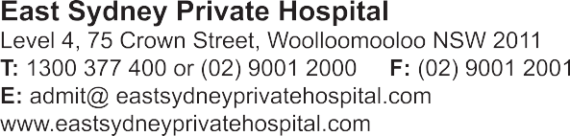

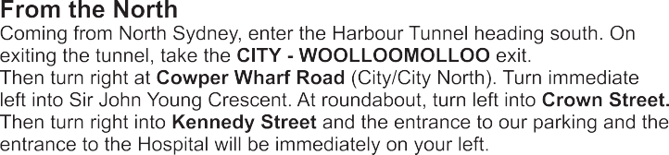
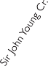
P
e
Kennedy Street
Riley Stert
Crown Street
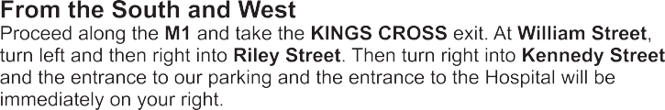
ESPH P
Suttor Street
P
William Street
t
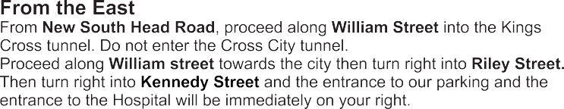

East Sydney Private Hospital

20 09/2014

